ОПРОСНЫЙ ЛИСТ ДЛЯ ЗАКАЗА ПРИВОДНЫХ БАРАБАНОВ

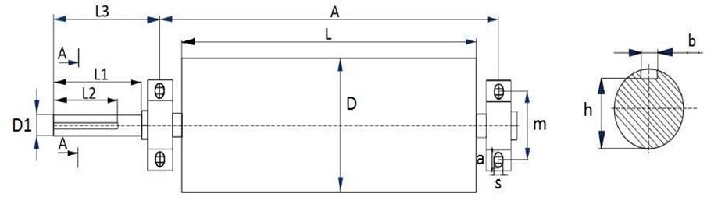

|  |  |  |  |  |  |  |  |  |  |  |  |  |  |
| --- | --- | --- | --- | --- | --- | --- | --- | --- | --- | --- | --- | --- | --- |
| **A** | **L** | **D** | **L1** | **L2** | **L3** | **D1** | **m** | **s** | **a** | **b** | **h** | **Подшипник** | **Кол-во** |
|  |  |  |  |  |  |  |  |  |  |  |  |  |  |
|  |  |  |  |  |  |  |  |  |  |  |  |  |  |
|  |  |  |  |  |  |  |  |  |  |  |  |  |  |
|  |  |  |  |  |  |  |  |  |  |  |  |  |  |

Контактные данные Заказчика

Предприятие* _______________________________________________________________

Адрес _____________________________________________________________________

Контактный телефон ___________________________________________________________

__________________________________________________________________________

Телефон отдела продаж: + 7 922 908 00 19. E-mail: info@stanwood.ru